**Enterprise Payment System (EPS)**

**Frequently Asked Questions (FAQs)**

Table of Contents

1. Enterprise Payment System 2

1.1 Supported Products 2

1.1.1 EPOBOL 3

1.1.2 Business Reply Mail (BRM) 3

1.1.3 Periodicals 4

1.1.4 Stamps 4

2 Account Set-up 5

2.1 Requesting Access 5

2.2 Migration 7

2.2.1 Linking Permits 7

2.2.2 Centralized Account Processing System (CAPS) Migration 8

2.3 User Roles 10

3 Funding Options 13

3.1 ACH Debit 14

3.2 Trust (Retail, Fedwire, ACH Credit, Mobile Check Deposit) 14

3.3 Funding as an MSP 15

3.4 Funding as a Mail Owner 16

4 Transactions 16

5 Mail Preparation and Postage Statement Changes 17

5.1 Mail Anywhere 17

5.2 Changes 18

5.3 What if I’m a PP or CPP 18

6 Reports 19

# Enterprise Payment System

## Supported Products

**What is the Enterprise Payment System?**

* The Enterprise Payment System or EPS allows customers to pay for products and services through an Enterprise Payment Account (EPA) funded as an Automated Clearing House (ACH) Debit, which allows automatic withdrawal from your bank account, or Trust Account, which allows you to prefund your account. The EPS payment account management provides enhanced security features, centralized balance and account management, and a self-service customer experience.

**What products and services does EPS support?**

* EPS supports commercial, domestic and international products and services which includes First-Class Mail®, USPS Marketing Mail™, Periodicals, PO Boxes, Caller Services and Reserve Services (EPOBOL) and Address Quality Products, (ACS, AEC, AECII). Below is a list of all products/services EPS does and does not support.

**Eligible Products/Services**

* PO Box, Caller & Reserve Services (EPOBOL)
* Address Quality Products (AEC, AECII and ACS)
* Priority Mail
* First-Class Mail, Letters, Cards, and Flats
* First-Class Package Service
* USPS Marketing Mail, Letters, Flats, and Parcels
* Parcel Select
* Media Mail
* Library Mail
* Bound Printed Matter
* Periodicals
* International Products
* Business Reply Mail (BRM)
* Every Door Direct Mail (EDDM) – BMEU

**Ineligible Products/Services**

* Electronic Verification System (eVS)
* Parcel Return Service (PRS)
* PC Postage
* Scan Based Payment (SBP)
* Merchandise Return Service (MRS)
* Official Mail Accounting System (OMAS)
* Premium Forwarding Service Commercial (PFSC)
* Pick Up on Demand
* Package Intercept
* Share Mail
* Intelligent Mail Barcode Accounting (IMbA)

**What submission types does EPS support?**

* EPS supports the following: Business Mail Entry Unit (BMEU) hard copy, eDoc (Mail.dat/Mail.XML), Postal Wizard and Intelligent Mail small business (IMsb) Tool.

**What permit types does EPS support?**

* EPS supports the following permit types: Permit Imprint, Metered, Pre-cancelled Stamps, Periodicals (CPP/PP), Postage Due and Business Reply.

**Can Postage Due Accounts be migrated to EPS? What is the security level of this account? Who has access to this account?**

* Postage Due can be migrated to EPS. Access to the account is restricted to the BCG user as granted access by the BSA. The bank account information is securely input outside of EPS and tokenized for security.

**Is package intercept supported by EPS?**

* This will be supported at a later date.

**When is EVS and PRS expected to be supported?**

* To be determined.

**When will OMAS be available in EPS?**

* This will be implemented but not at this time. No date is available at this time.

**If there is a need for report enhancements who do I direct those to?**

* Send to USPSPayment@usps.gov

**Does EPS work with non-profits?**

* Yes

**Can annual maintenance fees be paid using EPS?**

* At this time you can’t pay for annual fees using EPS, but this is a repair that is coming soon.

### EPOBOL

**Can I use the same EPS account for EPOBOL to pay for mailing services such as return mail, permits, etc.?**

* Yes, you would need to link the mailing services permits to your same existing EPS account that is being used for EPOBOL.

**My company has switched to the EPOBOL system, will the paper PO Box Service Fee Due notices be discontinued to avoid confusion since we are already handling the payment online?**

* Yes. However, in the transition from payment at the Post Office to payment via EPS there may be some overlap (i.e., the printed notification was printed prior to the link in EPOBOL). EPOBOL and the Post Offices utilize a single system of record (WebBATS) so the payment status as displayed in EPOBOL is current.

**Is EPOBOL, when utilized to open Caller Service account for existing customers only or can new customers open a Caller Service account? If they are, how is the verification completed and the Caller Service number assigned?**

* All EPOBOL customers are eligible to open a Caller Service. However, if the service is being opened at a new site, the customer should bring Photo ID and a copy of their EPOBOL confirmation to enable the Retail Office to confirm their identity at the first visit.

**I use EPOBOL, can we also pay our Post Office Box Renewal Fee?**

* Yes, you can pay your renewal fees through the EPOBOL system linked to your EPA.

**When opening caller service using EPS, how will the USPS verify the customer’s identity/information in order to begin service?**

* The customer should bring Photo ID and a copy of their EPOBOL confirmation to enable the Retail Office to confirm their identity at the first visit.

**Are PO Box notifications sent to Administrator, Payment Manager, and Subscriber or only Administrator?**

* Notification for renewals are not sent via email. You will be able to see when PO Box Renewals are due when you are logged into EPS.

### Business Reply Mail (BRM)

**What about paying for BRM, accounting fees, etc. that we use CAPS today. When will this be migrated to EPS?**

* These products are supported under EPS today.

**Will transfers between BRM accounts in different finance numbers be supported?**

* Multiple BRM accounts may be linked to a single EPA thus allowing the balance to be shared across accounts. If your organization chooses to use multiple EPAs, transfers are also allowed between payment accounts belonging to your organization.

**Will we still receive the daily receipts from the US Postal Service with Business reply and Postage dues?**

* Yes, you will continue to receive your daily receipts from the USPS.

**Is there some type of notification system for when a BRM account is running low on funds or would we need to check the accounts daily?**

* EPS allows a customer to subscribe to email notifications when the balance in their Advanced Deposit (Trust) account falls below the threshold set by their BSA.

### Periodicals

**How do I link my Periodical Publication to my EPA?**

* The request would need to be initiated from EPS, like any other migration request, and the permit/publication number will be linked to an EPS account using the Manage Permits page.

**As a Periodical mailer, how does EPS affect additional entry sites?**

* Creation of additional entry offices should not be affected at all, creation of additional entry offices will continue to occur and the PE being linked to an EPS account should not make a difference to the current procedure/process.

**If I am a Centralized Postage Payment (CPP) customer, when will I see the funds withdrawn from my EPA?**

* The funds will be withdrawn when the mailer/BMEU schedules a payment/if a payment is not scheduled then the mailer will be charged 28 days from the mailing date on the postage statement

**If I am a Pending Periodical (PP) mailer how will this work in EPS?**

* Mailers would need to link their PP permit and continue to process their mailings using the EPA. When the mailer requests for this PP account to be migrated, *PostalOne!* will transfer the available balance to EPA, *PostalOne!* will continue to track/account for the reserved balance. Once the PP is approved, the reserved balance on this PP will be transferred to the Periodical account created. If, and when, the Periodical is linked to the EPA, the permit balance is transferred to the EPA. If the Periodical does not get approved, then a Permit Imprint is created.

### Stamps

**Do pre-cancelled stamps need to be linked to an EPA?**

* Yes, you will have to link your pre-cancelled permit to EPS.

**If I am doing a Metered (MT)/Pre-cancelled (PC) Stamps mailing with additional postage due, do my permits have to be linked?**

* No, you can use a combination of permits/payment types when entering a statement with additional postage due.

**How can customers use EPA to purchase stamps?**

* The StampsNow program will be moved to Enterprise Payment System in late Summer early Fall 2018.

**When you say Pre-cancelled stamps do you mean we can buy them through EPS instead of using StampsNow?** **Or will they still need to be purchased through StampsNow?**

* The StampsNow system will be integrated with EPS to enable payment for purchases using your EPA late Summer early Fall 2018.

**Will this system replace Stamps.Com for CPU or Contract Postal Unit transactions?**

* Yes, the systems will interface together. Stamp purchases will be accessible through a link in the BCG.

**How will EPS affect mail houses that received cash advance to purchase pre-cancel stamps and mailings that don't meet 200 pieces threshold for standard mail and 500 pieces for FCM.**

* Cash advance for pre-cancel stamps – if doing this at the Post Office today, continue to do so – it would be outside of EPS. Stamp purchases will come in late Summer early Fall 2018 and you will be able to pay using your EPA for StampsNow purchases.
* Mailings that don’t meet the thresholds would be managed by the BMEU as they are today. Any assessments initiated by the BMEU could be paid through the EPS account.

# Account Set-up

## Requesting Access

**How do I enroll in EPS?**

* Currently, participation in EPS is by invitation only. To request an invitation code, contact the *PostalOne!* Helpdesk at1-800-522-9085 or PostalOne@USPS.gov, your local Business Mail Entry Unit or send an email to [USPSPayment@usps.gov](mailto:USPSPayment@usps.gov) Include the following information:
* Subject Line: “EPS Request”
* Name, Address, and Contact Information (email) for the BCG user who will be the EPS BSA
* CRID (Customer Registration ID)

You will receive an email from USPS within 2 business days. Note: The invitation code you receive is unique to the requestor and only grants the Business Service Administrator (BSA) access to EPS.

**How can a mailer request and retrieve an EPS Invitation code for EPS migration if the individual requesting is not the BSA for BCG or EPS. But they would like to become the BSA for EPS.**

* There are two scenarios.
  + **First Scenario is to Request Access to Business Location. This option will require the BSA of the location to request the invitation code.**
    - Create BCG Account in which user is assigned a CRID xxxxxxx1 but need access to CRID xxxxxxx2. This requires the user to request access to a location by selecting Add a Location from the manage account. The BSA for CRID xxxxxxx1 will then need to grant access. The BSA for the original CRID needed for EPS xxxxxxx1 will need to be the one to request the invitation code.
  + **Second Scenario is to create a new user account for the same CRID. With this option the new user can receive the invitation code.**
    - When creating a new BCG account select Company Identifier under Find my Address enter the CRID and select Find CRID. Once the CRID is found select Create Account. This will create a new user account for the CRID instead of assigning a new CRID.  The BSA for the CRID will then grant access to the services for the user. If they give BSA Delegate the user will be able to request the invitation code since they are now the same as the BSA. BSA Delegate gives the user the same access as the BSA.

**I’m a Mail Owner and would like to create an EPA. Do I need to know my Business Service Administrator (BSA)?**

* Yes, if you don’t know your BSA, you can contact the *PostalOne!* Helpdesk at (800)-522-9085 or [postalone@usps.gov](mailto:postalone@usps.gov) for assistance. You can also refer to the Payment Modernization Guide, sections 3.5, Requesting Access and section 3.6, Adding a Location (CRID).

**What if the invitation code requester and BSA aren’t the same person?**

* Anyone from the company can “request” an invitation code, but they must provide the BCG username and email address for the designated BSA to obtain an invitation code. If you need access to EPS work with your BSA to request the invitation code. They can than grant any user of the CRID access to EPS.

**I have been asked to become the BSA for EPS and I am still pending invitation. How do I go about getting approved?**

* You have to have an invitation code. If you have requested one please follow up with your local BME.

**Will EPS enrollment always be done using an invitation code?**

* No, open enrollment for EPS will begin in 2018. The exact date has not been determined. USPS will provide more information when it becomes available.

**Will a separate EPS invitation code be need for all three products, ACS, Commercial Products and Services, and EPOBOL?**

* No, you will get two codes, code for ACS and one code for Commercial Products and Services and EPOBOL.

**Do I need to zero out my permit balances prior to enrolling in EPS?**

* No, the balance on the account will migrate over to EPS upon final permit linkage (A permit cannot have a negative balance to link to EPA.)

**What happens if all of my permits are not linked to the EPS? i.e., 2 accounts are not linked but 5 are.**

* Permits linked to EPS will use the EPS account for payment. Permits still linked to CAPs, local trust etc. will continue to use that account for payments. If you do open an EPS account the money left in your CAPS account will not migrate over to EPS until the last CAPS permit has been linked to EPS.

**Is EPS mandatory to all business customers?**

* At this time it is not mandatory that business customers use EPS.

**Can we request for an onsite training for EPS?**

* Yes, reach out to your BME or BMS Analyst if you would like assistance setting up an onsite training.

**Are security settings available to allow a user to run reports and view transactions only?**

* Yes, you can grant someone the “Subscriber” user role which allows them to view reports.

**Can EPS be tested in the TEM environment?**

* At this time EPS does not have a TEM environment, there is a preproduction environment that is available for testing.

**If we have numerous BMEU - do we have to contact each of the locations?**

* No, you can contact one location that will assist you in the migration process.

**When can I start enrolling my CAPS accounts to EPS?**

* EPS is available for use effective February 1, 2018 for supported products.

**Is this EPS opened to all customers or just CAPS customers now?**

* It is open to all customers.

## Migration

### Linking Permits

**Who can help us gather info on our permits? We have many locations and legacy subsidiary names. City state of permit. Does it include PO Box and caller numbers?**

* The USPS *PostalOne!* Helpdesk or your local BME can assist with confirming your permit information. Verification of your PO Box and Caller Services is also currently supported. An EPOBOL migration spreadsheet is available on PostalPro with the recommended information to verify PO Box, Caller and Reserve Services registration.

**What happens to the current balance on a permit at my local BMEU?**

* When the Local Trust Permit is linked to an EPS Account, the balance will automatically migrate over to EPA.

**Do you have to be the permit holder in order to link a permit to your account?**

* You must have Manage Payment access to an active EPA and have Manage Mailing Activity for the permit in order to establish or modify linkages.

**When I link my existing permit to my EPS Account, will the permit number change?**

* No, when linking your permits to your EPS Account the numbers will not change.

**What happens with existing balances on Local Trust Permits or CAPS Trust balance when the permit is now added to EPS with ACH payment? Will the balance be used first prior to pulling funds from the bank account?**

* The Local Trust and CAPS Trust balance will migrate over to the Enterprise Payment Account and post to the Trust account. The primary payment method is not changed from ACH Debit to Trust so the transactions will continue to post to the ACH Debit payment method and sent to the customer’s bank.
* To use the Trust Balance the Primary Payment Method will need to be changed to Trust. The change to the payment method will be updated at 6pm EST (5pm CST). Transactions will continue to post to the ACH Debit until the change takes place.
* EPS administrators or payment managers may also request a Withdrawal of the unused Trust funds through EPS.

**Will they have to move all permits at one time?**

* No, all migration does not have to happen at once.

**Will I need to delink all my permits from CAPS?**

* No, this will happen automatically.

**Will I need to hand key all my permit numbers into EPS?**

* No, permits will automatically link from CRIDs.

**Can the same permit be linked to multiple EPAs?**

* No, you can only link one permit to one EPA.

**Will you have to re-establish payment links in EPS or will they migrate automatically from CAPS?**

* You will have to re-establish payment links.

**If I have an existing CAPS account, will the permits auto-link to EPS account or do I have to add them individually?**

* Once your EPS account (EPA) is ready for linkage - you will need to link each Permit to your EPA individually.

**Do I need to link only PI or also PC MT?**

* If you use your PI to pay additional postage on your PC mailings you will need to link both.

**Is there a limit to the number of permits we can link to one EPA?**

* No

**Do our permit balances need to be $0 before we link them to a debit EPA?**

* No, the balance will automatically transfer upon last linked permit.

### Centralized Account Processing System (CAPS) Migration

**If I sign up for my Enterprise Payment Account (EPA) using my CAPS account, will my CAPS account number be used as my EPS account number?**

* The EPA number will be your CAPS account number beginning with “90000” to reach the 10 character requirement for an EPA number. A current CAPS PIN is required to verify the CAPS account number.

**I’m a mailer who uses multiple CAPS accounts. Do I need a different EPS invitation code for each CAPS account?**

* No, the EPS invitation code allows you to initially sign-in and access EPS. From there you can setup multiple EPS accounts however you see fit.

**I currently have multiple CAPS accounts, will I be required to create the same number of EPS accounts or can I consolidate them to a single EPS account?**

* EPS accounts do not need to recreate the exact linkage of your organization’s current permits-to-CAPS account configuration. Any permits currently linked to a CAPS account can be linked to your EPAs in any configuration you choose (provided you have access to Manage Mailing Activity for the permits you wish to link to an EPA).

**I know Mail Anywhere works with a CAPS account. However in the Mail.dat file, it requires the sender to put in the account number for the mailing. If multiple permits have the same account Number, will the system still accept the mailing?**

* Yes, the mailer would provide the EPS Account number instead of the CAPS account number.

**Can you transfer funds from CAPS to EPS when it is set up?**

* The funds will transfer automatically upon final permit or service linkage. Example: If all permits are linked to EPS but the CAPS account is used to pay for Address Quality products, the balance will not migrate until you link your address quality products.

**If we have a CAPS Account, do we have to re-set up all banking information with the ACH Debit, or can the stored CAPS information be transferred over when moving to the new system?**

* Yes, due to the additional security added within the EPA and the validation of bank account information.

**Will we be able to use the CAPS ref# on the bank statements to charge different GL accounts for different budgets/groups/affiliates?**

* The information displayed on bank statements varies between financial institutions, but will always include the 10-digit EPS account number. Additional information for reconciling financial transactions (including the customer reference number when provided) is displayed on EPS transaction reports and included in the downloadable reports.

**Will we be able to use our current payment method used for our CAPS?**

* Yes, EPS allows ACH Debit, and Trust funded by cash, check, money order, FedWire and ACH credit deposit.

**For CAPS we use a vendor as middle man to manage payments; does EPS eliminate the vendor and mailer can pay directly to the USPS?**

* EPS does not change the process, either a vendor can be used or the mail owner can establish their EPA.

**Currently, clerks at BMEU will check to see if sufficient funds are in deposit in the CAPS account. If using ACH Debit for EPS, will the clerks accept mailing with expectations of payment at end of day?**

* Yes, the transactions will be finalized in *PostalOne!* and sent to EPS.

**Is the CAPS system being retired? If yes, what date will CAPS no longer available for use.**

* The CAPS system is being replaced by EPS, we do not have a date for retirement, however we strongly encourage that mailers start the migration process.

**Is there plan for communications for CAPS when it is being retired?**

* Yes, there will be advisories sent to all customers.

**We use CAPS and if we didn't have enough money in our account (by accident), our mail would not go anywhere. With this new system, if our account doesn't have enough funds to cover a particular mailing, will our mail be held up until funds are added?**

* Yes, the process will remain the same as it is today. We encourage mailers to use ACH debit for this reason.

**Does CAPS need to be contacted to cancel an existing CAPS account once transition to EPS is complete?**

* Upon final product/service linkage the CAPS account will be closed without further interaction needed.

**My company merged and we are going to eventually combine all into one EPS account, should I migrate my CAPS to EPS now or wait?**

* You can begin the migration now.

**After I move last permit from CAPS is migrated to EPS, how long does it take to move the remaining balance from CAPS?**

* Instantly, at most 5-10 minutes.

**How do I know when all my CAPS permits are moved over to EPS?**

* All permits will show in the ‘Manage Permits’ screen in EPS.

**I have multiple EPAs and one CAPS account. I am linking my permits to two separate EPAs, but permits are coming from the same CAPS account. When I link the last permit to EPA, how does CAPS know where to put the balance of the CAPS funds?**

* The last permit linked will get the balance of CAPS funds. From here you can transfer the money between EPAs, if needed.

**Can current CAPS members open new CAPS accounts?**

* Yes, but we are encouraging customers to move to EPS.

**What will happen to CAPS accounts that have not migrated by the time CAPS is retired?**

* USPS will work with all customers to get their accounts migrated to EPS before CAPS is retired. USPS is working on a plan for the accounts that do not get migrated that will be communicated to customers when complete.

**Will there be steps sent to CAPS customers to migrate?**

* After the request to migrate to EPS is made directions will be sent via email from USPS.

**When working with a BME are you working with one throughout the migration or whoever is available?**

* You will have a main POC.

## User Roles

**What are the user roles for EPS?**

* The first person to request access to EPS is assigned the Administrator role. The Administrator will approve/deny additional users who request access.

Administrator:

* Grant access for additional EPS users
* Manage payment account (open/close accounts, approve products to be paid through account, perform transfers and withdrawals)
* View and download payment transaction reports

Payment Manager:

* Manage payment account (open accounts, approve products to be paid through account, perform transfers and withdrawals
* View and download payment transaction reports

Subscriber:

* View and download payment transaction reports

**Can I request access and have the request go directly to the BSA?**

* Yes, the notification goes to the BSA or anyone the BSA has made an Administrator.

**I am a Mail Owner, how do I give someone access to my EPA?**

* The person requesting access must sign-in to the BCG and add the CRID associated with the account, and request access to EPS through the BCG.

The steps for this process are outlined in Section 3.6, Adding a Location (CRID), of the Payment Modernization Enterprise Payment System document located on PostalPro. Then the EPA Administrator for your account needs to sign-in to the BCG and grant the access level next to the name of the person requesting access.

The steps for this process are outlined in Section 3.4, Business Service Administrator (BSA) of the Payment Modernization Enterprise Payment System document located on PostalPro.

**What EPS activity will be visible to the person requesting access to my EPA?**

* Granting a person any access level to your EPA will allow them to see ***all*** transactions associated with your account. It is not limited to the ones they are involved in.

**What EPS role do I need to access EPS transaction reports?**

* You can view the Transaction Report with any user access – administrator, payment manager or subscriber read only.

**Can more than one administrator be assigned to a single EPS account?**

* Yes, EPS Administrators must have BSA or BSA delegate access to the Enterprise Payment service.

**Can my BSN specialist assigned to my company have access to my accounts so she can help me?**

* The BSN does not have access to your accounts, however you can contact the *PostalOne!* Helpdesk or your local BMEU for assistance.

**Can we have multiple employees able to log into the EPS system?**

* Yes, each employee will have need a unique BCG login and can be granted access to the EPS.

**Can you make more logins with limited capabilities that members of accounting can use without being able to make changes accidentally elsewhere?**

* Yes, there are different roles (Administrator, Payment Manager, and Subscriber) within the EPS.

**How do I add a Customer Registration ID (CRID) to EPS?**

* To request access to EPS as a BCG user without access to the CRID, you must first add the CRID to your profile. To do this, login to the BCG and select “Manage Account” on the left hand side.

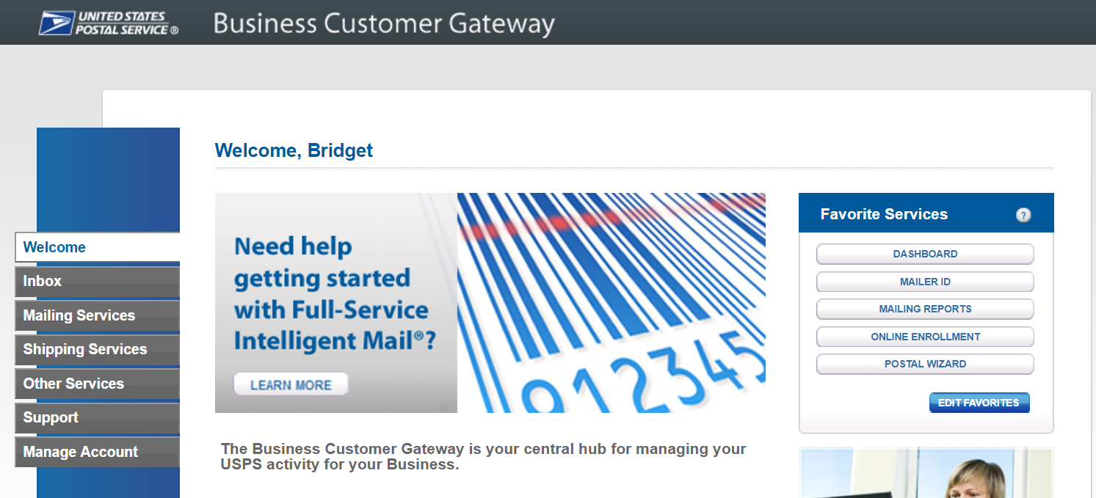

Then select “Manage Profile” at the top and “Add A Location” to add the CRID to your profile.

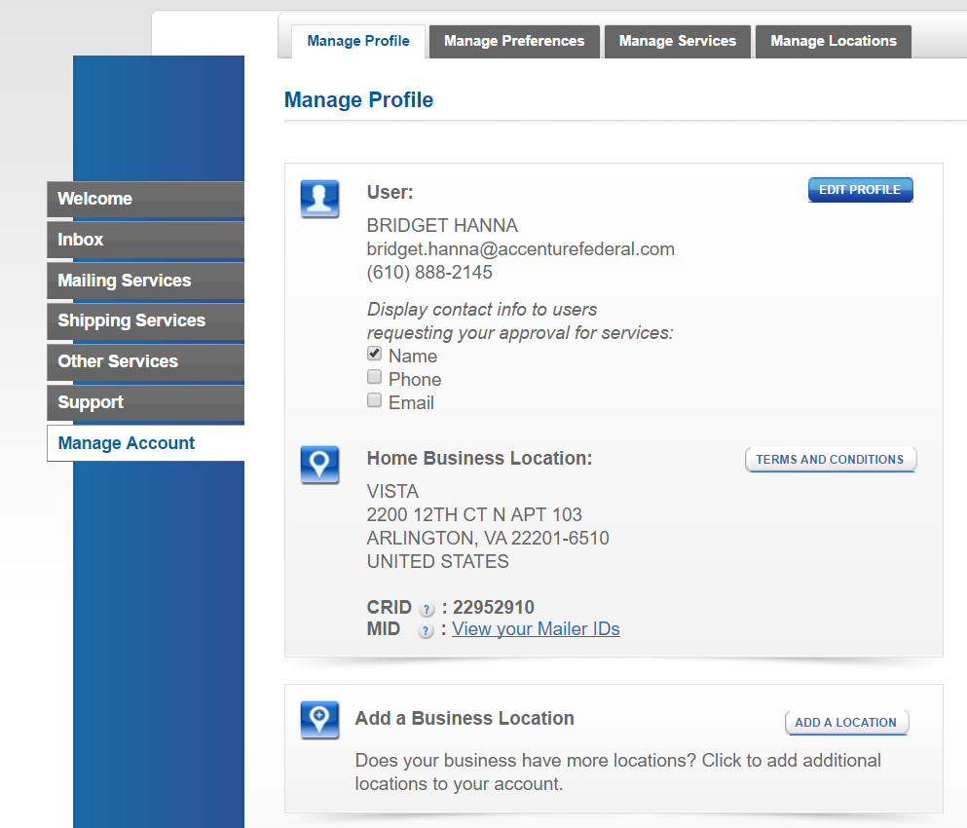

Jim’s Candies

Jim Brown

You may now request access to Enterprise Payment. Select “Other Services” on the left hand side. Then select “Go to Service” next to Enterprise Payment.

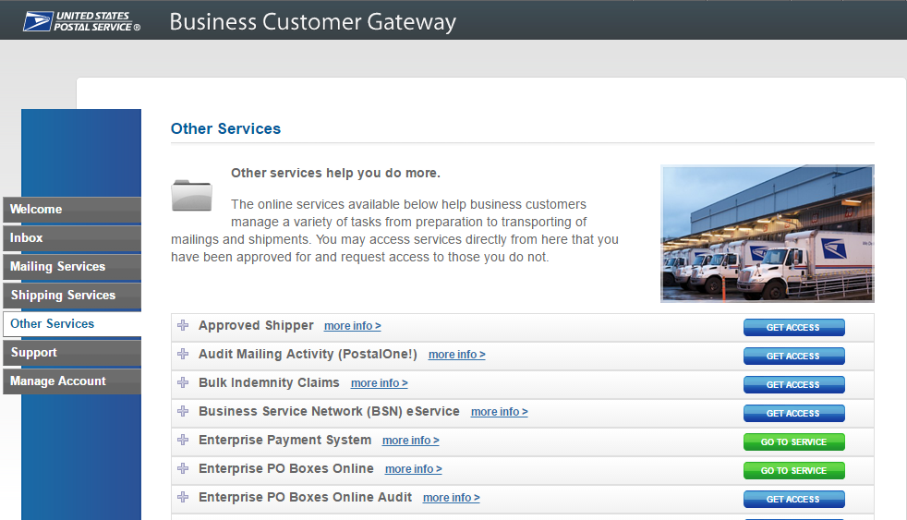

The designated BSA must now approve your request to EPS before you are given access.

**Will I be able to view permits not linked to my CRID?**

* EPS returns all permits that you have ‘Manage Mailing Activity’ to in the BCG, this enables multiple permits to be tied to a central EPS account, but still maintain the permit to CRID linkage.

If customers want to manage accounts at the CRID level, multiple EPAs can be established pulling from a central bank account. This enables authorization at the EPA level, so one person can view one EPA account, but not the other if need be.

**As a Mail Owner how do I give my Mail Service Provider (MSP) access to an EPS account?**

* To do so, the Mail Owner **completes steps 3&4** of the process below:
  1. The MSP logs into BCG and adds the CRID on that EPS account to the BCG account
  2. MSP requests access to EPS service under that CRID
  3. ***BSA (assumed to be Mail Owner) grants access to EPS Service to MSP BCG user***
  4. ***EPS Account Administrator adds MSP BCG user to the EPS Account*** 
     1. ***for read-only report access, the role granted is Subscriber***

Note: This will grant the MSP user access to view ALL transactions on the EPS reports, even if some transactions were made by other MSPs.

**Today separate groups manage different postal products; when we transition to EPA, will we be able to maintain the separate management/payment of each product?**

* You can have multiple EPAs in which products can be linked to different accounts to keep the separation.

**If we convert PO Boxes, ACS, and Business Reply Mail, will we have three separate EPA numbers?**

* You have an option to use one EPA or multiple.

**Will there be an external link to access the EPA or is it strictly through the gateway?**

* The user will have to set up a BCG account to access the EPS

**Whom on a local level would I gather more information about this system. My BMEU clerk or local postmaster?**

* Contact your local BMEU.

**Who will receive the automatic renewal notices?**

* The Administrator or people who have the “Payment Manager” role.

# Funding Options

| **Funding Method** | **Description** | **Account Information Needed from Mail Owner** | **Deposit Available** |
| --- | --- | --- | --- |
| **Automated Clearing House (ACH) Credit** | Electronic method to deposit funds into your account directly from your banking institution | * Bank Name * Routing Number * Bank Account Number | * Next day |
| **Fedwire Transfer** | Service provided by the Federal Reserve bank to electronically deposit funds into your account | * Bank Name * Routing Number * Bank Account Number | * 4 to 6 hours |
| **Deposit at Retail Unit** | Deposit check, cash, or money order at designated retail units (<https://postalpro.usps.com/EPS/RetailLocations>) | * 10-digit EPS Account Number | * Near real-time * A limited number of retail locations do not have real-time processing. In these cases, funds are available the next business day, but mailings are not held. |
| **Mobile Check Capture (Future)** | Capture a check image, using the camera on your Android smartphone, iPhone or iPad, and deposit funds from anywhere | * 10-digit EPS Account Number | * 4 to 6 hours |

**Will USPS' bank - Wells Fargo Bank be changing?**

* No, USPS bank will still be Wells Fargo

## ACH Debit

**When does an ACH Debit get processed from my EPS account?**

* The debit transactions are aggregated daily (6 pm Eastern) and sent to your bank for withdrawal, generally posting to your account within 1-2 business days.

**What payment options are most of your customers selecting?**

* ACH Debit is the most frequently used method.

**If I drop off 7 jobs will the bank submission be one line item for all jobs or will there be 7 individual submissions (one for each job) to the bank account?**

* There will be one aggregated withdrawal from your bank account. Within EPS they will show as individual transactions.

**What reference # will appear on the Bank Statements?**

* USPS sends the 10-digit Enterprise Payment Account number to customer financial institutions for display on the Bank Statements and activity reports.

**Can I deposit advanced funds into a ACH Debit account?**

* No, advanced funds can only go into a Trust account not a ACH debit account.

## Trust (Retail, Fedwire, ACH Credit, Mobile Check Deposit)

**Can I deposit a check using my mobile device?**

* This functionality is coming soon.

**How do I get access to the mobile app?**

* To enroll for mobile check capture, contact the *PostalOne!* Helpdesk at 1-800-522-9085 or PostalOne@USPS.gov or your local Business Mail Entry Unit. You must include EPS account numbers you wish to enroll.

**Can I use a credit card to pay for all products with my EPS account?**

* No, the only products planned to allow Credit Card are Stamps Fulfillment Services products (e.g., StampsNow).

**I saw in the NPF brochure a mention of a new digital currency for the post office - Mailcoin. Do you plan to attempt this as future payment?**

* This is an external vendor product that is not supported as a payment method in EPS.

**Can a Trust Account run into a negative balance?**

* It can if an override is performed by the BMEU acceptance employee.

**We have a Local Trust as well as an ACH Debit tied to the same EPA#. How do we indicate which account to use at the time of mailing?**

* In EPS you can identify which account to use as the primary payment method.

## Funding as an MSP

**How can I check my account balance to see if I have enough funds to cover a mailing?**

* The account balance for each EPA you have access to will show on your EPS home page. Additionally, the BME clerk has access to the account balance through their “Balance and Fees” screen in *PostalOne!*.

**Will any interest be paid on balance of money held in the EPS Account?**

* No interest will be paid on balances.

**Can I Fund a Mail Owner’s Account as an MSP?**

* Yes, as an MSP you have the ability to deposit money into a Mail Owner’s Trust Account without an assigned role to the account.

**If a client pays me, MSP, with a check made out to the USPS / US Postmaster, can I deposit that check to my EPS account? In most cases our clients pay for their mailings by making a check out to our company and we fund through our CAPS account.**

* Yes, you can deposit into your EPA. The holder of the EPA is responsible for any negative balances, check returns etc.

**As an MSP can I make a Mobile Check Capture deposit into my client’s EPA?**

* Yes, you will need the 10-digit EPS Account number to make the deposit.

**I am a Mail Service Provider (MSP). How do I set-up my customer’s EPA?**

ACH Debit: The MSP will need to have access to the Mail Owner’s bank account information. The MSP will then need the Mail Owner to either:

* Enter the micro-debit verification transaction
* Give the values of the verification to the MSP to verify the account

Trust Account: The MSP would need to set-up an EPA on behalf of the Mail Owner. Then the MSP would fund the Trust Account. Note: A Trust Account is automatically set-up when the EPA is created.

**As an MSP, we have mail owners that fill out a permit application and send a check for us to give to the local Post Office for opening a permit on their behalf. Will this still be an option or will the mail owner need to set up an EPS in the BCG?**

* The mail owner would need to set up their EPA or the MSP could open the permit under their CRID and EPA.

**As an MSP, I am able to use the BCG to verify a client's permit number and the account number for that permit. If a client changes to EPA will the account number in the BCG be updated (and maybe indicate it is an EPA account)?**

* Yes, this will be updated to include the 10 Digit EPA.

**As a MSP, how do I gain access to a Mail Owner’s EPS Account to view transaction data?**

* The Mail Owner must grant you access to their EPS Account. To do so, the MSP **completes steps 1&2** below:

1. ***The MSP logs into BCG and adds the CRID on that EPS account to the BCG account***
2. ***MSP requests access to EPS service under that CRID***
3. BSA (assumed to be Mail Owner) grants access to EPS Service to MSP BCG user
4. EPS Account Administrator adds MSP BCG user to the EPS account
   1. for read-only report access, the role granted is Subscriber

**Can I change my funding option between ACH Debit and Trust account throughout the day?**

* No, you can’t change the method of payment for the day. There is no way to know when the mailings will be accepted at the mail entry unit. You can change the funding method used from day to day.

**Will we be able to pay at the post office without an EPA after go live? I am at the corporate level managing several hundred CAPS accounts for our publications we own. There are some of our publications with permits not currently linked to a CAPS account. Will they be able to take a check to the post office or would we have to set up an EPA for their permit?**

* If you have not migrated to EPS, you will make deposit or payments as you do now. Once you are migrated to EPS you can make deposits at any Retail Window with RSS as long as you have EPS account number.  If the Permit is not linked to CAPS as long as you have Manage Mailing Activity approval in BCG you will be able to link those Permit to your EPS account.

**I normally provide a postage letter of how much and where to wire to CAPS to my customers, do you have a template (EPS) for us to follow?**

* No, there is no template. Complete list of deposit instructions are available in EPS when a payment method is chosen on the Payment Method Setup Screen.

**As an MSP do I need to have access to the mail owners EPA numbers?**

* If the mail owner is funding the account you will not have to.
* If you fund the EPA for them, then you would need to know their EPA number.

## Funding as a Mail Owner

**As a Mail Owner can I transfer funds from my EPS to a MSP's EPS account?**

* No, you cannot transfer funds online, however you can deposit cash, check or money order at any retail location using the 10-digit EPA number or you can do a FedWire or ACH Credit deposit.

**Our MSP handles our 3 permits for our CAPS account. Do they need to take any action?**

* This is a conversation you will have to have with your MSP. You can either open the EPS account or they can open the EPS account for you.

# Transactions

**Do I still have to make deposits via check at my local office where the permit is held?**

* No, deposits can be made at any retail location that has an RSS. A list of location can be found on PostalPro here: <https://postalpro.usps.com/EPS/RetailLocations>

**What information is required to make a deposit?**

* You will need to know your 10 digit EPS Account number. **Note:** The retail location will not be able to find this information. If you do not know your 10 digit EPS Account number you will need to contact your local BMEU.

**Where do I see deposits made?**

* Deposits made to your account will be displayed in the Transaction History report.

**Can I transfer money from an EPS permit to a non-EPS permit?**

* No, you cannot transfer from EPS permit to non-EPS permits.
* You can transfer from EPS Trust to EPS Trust if you have authorization as Payment Manager or Administrator to both EPS accounts.
* If you don’t have these permission you can still make a deposit at an RSS as long as you have the EPS account number.

**We often receive BRMs back with a stamp affixed. We submit those stamped BRMs for a refund, we normally receive a check for a refund - can those checks be linked to our EPS to go via ACH back into our acct rather than waiting on a check to be mailed?**

* Refunds will be made directly to your EPA.

**How will EPS affect VAR?**

* VAR's will now be deposited into your EPA, eliminating the need to cut a paper check.

**How does this new system affect my company as we mail for multiple customers using their permits and CAPS accounts, and use both Mail.dat files and *PostalOne!*?**

* The new system will not affect your mailing processes, the payments for transactions linked to EPS will flow through the system. If you use the account number in the .mpa field this will need to be updated to the new EPA number.

**I am a MSP and my customer has linked a permit to EPA. Can I present a combined mailing with permits linked to a CAPS account, a local trust and an EPA?**

* Yes. The system will perform the following transactions based on the account type. The MSP can view the Postage Statement transaction details in *PostalOne!.*The customer will see the transaction for their portion of the mailing within EPS.

CAPS:The system will route the transaction amount to CAPS.

EPA:The system will route the transaction amount to EPA.

Local Trust: The funds will be withdrawn from the account.

**What happens if a postage statement was submitted and finalized through CAPS or Local Trust and then migrates to EPS?  Can I do a reversal?  Does the money go to EPS?**

**CAPS DEBIT**

* Permit is CAPS DEBIT
* Postage Statement is submitted and finalized (Money is being collected from CAPS)
* Permit is now migrated to EPS
* Postage Statement is reversed.
  + If the original transaction is still pending on CAPS side, meaning if the money was not collected yet, we send the reversal to CAPS.
  + If the original transaction is not pending, meaning the money was already collected, we send the reversal to EPS.

**CAPS CREDIT and LOCAL TRUST**

* Permit is CAPS CREDIT or LOCAL TRUST
* Postage Statement is submitted and finalized (Money is being collected from CAPS)
* Permit is now migrated to EPS
* Postage Statement is reversed.
  + Postal One always sends the reversal to EPS for CAPS CREDIT and LOCAL TRUST

# Mail Preparation and Postage Statement Changes

## Mail Anywhere

**Can I use Mail Anywhere with EPS?**

* Yes, the mailer would provide the EPS Account number instead of the National Account Number.

## Changes

**Will the paper submission be changed to electronic?**

* Yes, this process eliminates most paper transaction processes.

**Can I email a postage statement from that site directly to a customer? If not, can I download a pdf of postage statement so that I can email it to them?**

* A PDF of the postage statement can be downloaded from the BCG and emailed to the customer.

**What changes are there for submitting the different types of Postage Statements (hardcopy, PW, .dat, .xml)?**

| Type | Changes |
| --- | --- |
| BMEU Hardcopy Submission | * No changes; continue using existing permit number. * If you enter information in the CAPS reference ID field this will be sent to EPS and displayed on transaction reports. |
| Postal Wizard | * No changes; continue using existing permit number, account number displayed will reflect Enterprise Payment Account. * For Mail Anywhere jobs continue entering the mailing facility location. |
| Mail.dat | * Continue entering the permit number or publication number in the existing .mpa publication field or permit number field. * The .mpa account number field remains optional, however if populated it must match the Account Number linked to the permit number. * For Mail Anywhere update the .mpa account number field with the Enterprise Payment Account Number. * If you enter information in the CAPS reference ID field this will be sent to the EPS and displayed on transaction reports. |
| Mail.XML | * Continue entering the permit number or publication number in the existing Permit Number/Publication field. * The account number remains optional, however if populated it must match the Account Number linked to the permit number. * For Mail Anywhere update the payment account number field with the Enterprise Payment Account Number. * If you enter information in the CAPS reference ID field this will be sent to the EPS and displayed on transaction reports. |

**What security do we have to prevent unauthorized mailings?**

* If any unauthorized activity occurs USPS has the ability to suspend the account while researching the suspicious transaction.

## What if I’m a PP or CPP

**Will I be able to pay for a customer's mailing using their permit while they still pay for their own mailings using their deposit account?**

* Yes, you can continue paying for customer mailings and they can also pay for their own.

**In a combined mailing we have multiple permits. Some permits owned by the MSP and some owned by the Mail Owner. As we transition will it be OK to use some permits linked to CAPS and other permits linked to EPA within a mailing?**

* Yes, you can have a combination of payment methods in one mailing.

**If I am submitting the mail (eDoc submitter), but not the mail owner/permit owner does that permit need to be moved over to EPA if it’s associated with a CAPS account?**

* Yes, the mail owner would have to migrate the permit to EPS. The eDoc submitter does not have to do anything different unless it is for Mail Anywhere.

**Will vendors be forced to use one CRID?**

* Vendors can use multiple CRIDS as they do today.

# Reports

**What EPS data will be available on the Business Customer Gateway home page?**

* As part of a future enhancement, users will be able to view summary spend data on a specific CRID or Permit from the Business Customer Gateway home page.

**What capabilities will I have for gathering large sets of recurring data?**

* A Bulk Data Transfer is planned for a future release, which will allow mailers to choose certain data they want to have pushed to them on a given interval.

**What other future reporting capabilities are planned?**

* USPS will build a transaction reporting datastore with detailed transaction level data on all EPS and *PostalOne!* products. This includes EPS transaction data from all EPS source systems as well as *PostalOne!* detailed postage statement data. Users will be able to view this data through a separate interface that will allow increased capabilities for customized reporting. Full details on the data elements included in the data store will be distributed to mailers as they become available.

**Where does your permit ending balance show in EPS?**

* The ending balance shows on the homepage of EPS when you login. You no longer drill into Transaction Report to see the balance. EPS maintains balance at the EPA level rather than at the individual permit.

**How do I print out the EPS report? The report font prints very small and unreadable.**

* In the Print Window, select Custom Scale and decrease the percentage until the page is scaled to display the report fully on one page. See images below:
* Below, at 100% scale, part of the report is not in the print window. The scale must be reduced for the report to fit on one page.

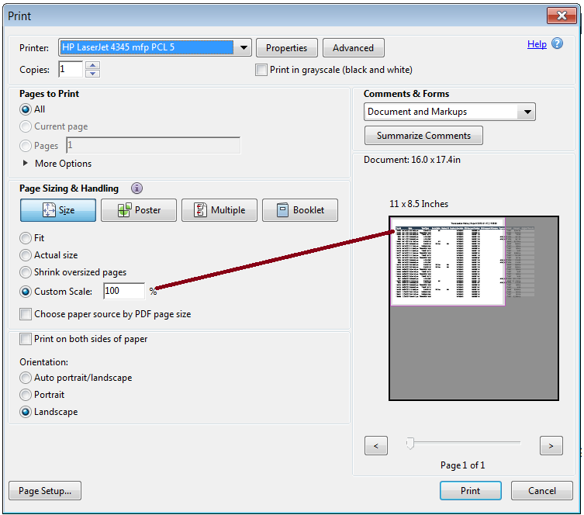

* Below, the scale has been reduced to 78%. The report is no longer hanging off of the page to be printed. The printed report is bigger and easier to read.

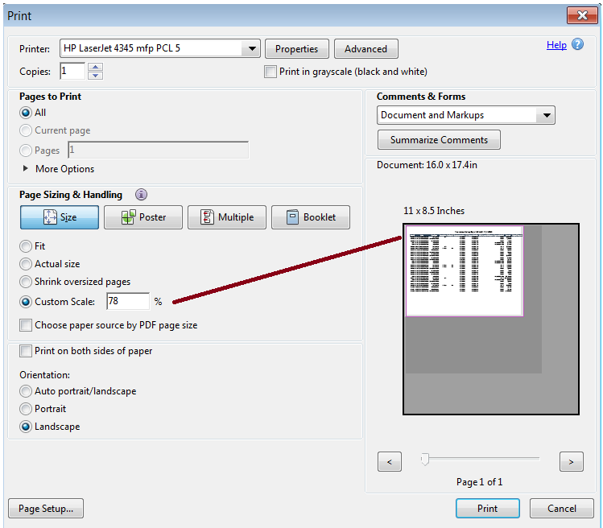

**Can I limit what is shown in reports (e.g., can I just run a Permit Imprint report)?**

* The EPS reports do have a filter capability.

**Will these reports replace the mailing summary reports available on the gateway or in addition to because they are tied directly to the financial side?**

* Both sets of reports will remain in place until a later date at which USPS will consolidate views.

**Do the transactions reports include the PO Box, Caller or permit number as well as city, state?**

* PO Box or caller is not displayed on transaction history report or PO Boxes Details report.
* City/State is displayed on PO Boxes Details report. (Box/caller ID is not assigned until the box is validated in WebBATS.)
* For *PostalOne!* Transactions, the permit number/type/City/State/ZIP are not displayed on the Transaction History report.
* Permit number/type, City/State is displayed on Mailing Details Report for purchases, but not for adjustments, reversals or refunds.

**Is there a way we can put our internal identifiers so we can use the transaction reports to reallocate charges to business units?**

* The accounts can have nicknames associated to them.

**Can the Job ID (our internal job number, submitted in mail.dat) of a mailing be included in reports?**

* Job ID is not on the Transaction History Report but it is available on the Mailing Details Report and the Mail Class drill down from the Account Overview page.

**Are reports customizable?**

* No, but there are capabilities to filter the data.

**How much transaction history will be retained and available on EPS?**

* EPS will retain Transaction History in EPS for 24 months.

**Is the "Transaction History Report" similar to the CAPS transaction display?**

* The EPS reports have more detail than the CAPS reports. There is also drill-down functionality within the EPS reports.

**How much legacy transaction history will be retained and available in EPS?**

* Legacy CAPS transaction data will not be accessible through EPS
* Legacy CAPS transaction data will remain available in CAPS for the current retention period (12 months) from the date of the transaction.

**With the drill-down reporting, in the Postage Statement Report will number of pieces be correct to the actual number of pieces for the cost?**

* Yes, reports are updated as soon as a transaction is posted in EPS.

**In CAPS, there is a reference field where we can enter a job ID # so we know how to allocate the postage. Is there still a reference field that will be available on the EPS reports?**

* Anywhere with a reference field linking to a CAPS account you will have to change this to the EPA number